Build a smart home in tinkercad use atleast 2 sensor, LED, Buzzer in a circuits simulate in a single code

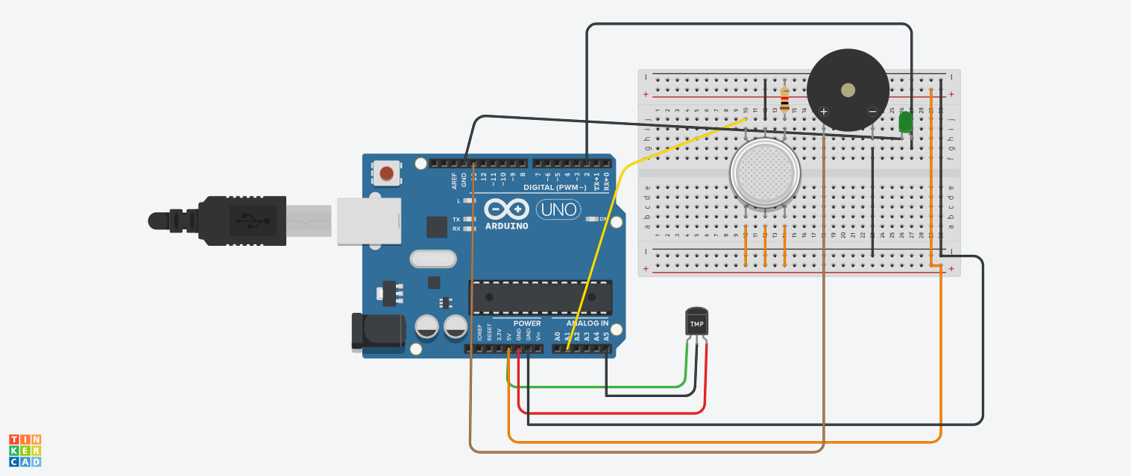

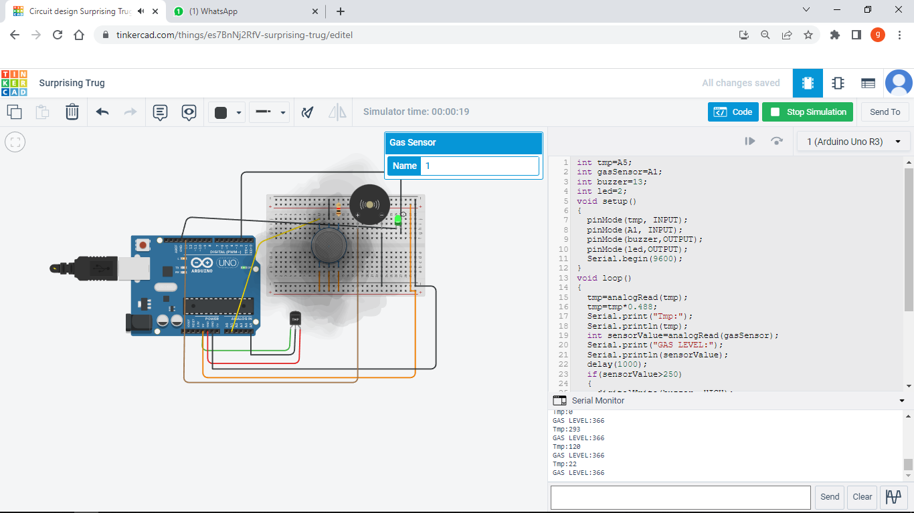

int tmp=A5;

int gasSensor=A1;

int buzzer=13;

int led=2;

void setup()

{

pinMode(tmp, INPUT);

pinMode(A1, INPUT);

pinMode(buzzer,OUTPUT);

pinMode(led,OUTPUT);

Serial.begin(9600);

}

void loop()

{

tmp=analogRead(tmp);

tmp=tmp\*0.488;

Serial.print("Tmp:");

Serial.println(tmp);

int sensorValue=analogRead(gasSensor);

Serial.print("GAS LEVEL:");

Serial.println(sensorValue);

delay(1000);

if(sensorValue>250)

{

digitalWrite(buzzer, HIGH);

digitalWrite(led, HIGH);

}

else

{

digitalWrite(buzzer, LOW);

digitalWrite(led, LOW);

}

}